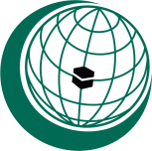
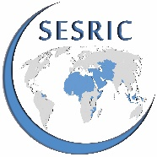
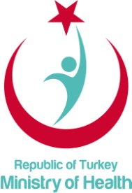
WORKSHOP ON
“INTEGRATION OF THE TRADITIONAL AND COMPLEMENTARY MEDICINE PRACTICES INTO THE HEALTH SYSTEMS AND HEALTH SERVICES OF OIC MEMBER STATES”
18 April 2018, Istanbul, Turkey
Work Programme
09.00 - 09.30 | Registration
09.30 - 10.00 | Opening Session  Recitation from the Holy Quran  Welcoming and opening remarks:  - Statement of Amb. Musa Kulaklıkaya, Director General, SESRIC  - Prof. Eyüp Gümüş, Undersecretary, Ministry of Health of the Republic of Turkey  - Sümeyye Erdoğan Bayraktar, Vice President, Women and Democracy Association
10.00 - 10.45 | WHO Traditional Medicine Strategy 2014-2023  - Dr. Qi Zhang, Head of Traditional and Complementary Medicine Unit, WHO  - Questions and answers
10.45 - 11.15 | Coffee break
11.15 - 11.45 | OIC Strategic Health Programme of Action (SHPA)  - Fatima Zahra Kamal, Technical Cooperation Specialist, SESRIC  - Questions and answers
11.45 - 12.30 | Traditional and Complementary Medicine under the SHPA 1st Thematic Area: “Health System Strengthening”  - Dr. Mehmet Zafer Kalaycı, Director of Traditional and Complementary Medicine Department, Ministry of Health of Turkey  - Questions and answers
12.30 - 14.00 | Lunch and prayer break
14.00 - 15.30 | Member States’ experience and best practices (I)  Co-moderators:  Assoc. Prof. Salih Mollahaliloğlu, Health Advisor, SESRIC  Mehmet Fatih Serenli, Director of Training and Technical Cooperation, SESRIC  - Member States’ interventions on integration of the traditional and complementary medicine practices into their national health systems and health services (5 min. for each)  - General debate and discussion on the way forward towards enhancing intra-OIC cooperation
15.30 - 16.00  16.00 - 17.30 | Coffee break  Member States’ experience and best practices (II)  Co-moderators:  Assoc. Prof. Salih Mollahaliloğlu, Health Advisor, SESRIC  Mehmet Fatih Serenli, Director of Training and Technical Cooperation, SESRIC  - Member States’ interventions on integration of the traditional and complementary medicine practices into their national health systems and health services (5 min. for each)  - General debate and discussion on the way forward towards enhancing intra-OIC cooperation
17.30 - 18.00 | Wrap up of recommendations and closure of the Workshop

