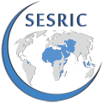

WORKSHOP ON
IMPROVING THE STATE OF ELDERLY IN OIC MEMBER STATES

24-25 April 2018, Jeddah, Saudi Arabia

Draft Agenda

- Opening of the workshop
- Current state of elderly in OIC Member States
- Perspectives of international and regional organisations on addressing challenges faced by elderly
- National practices and perspectives on addressing challenges faced by elderly in OIC Member States
- Recommendations for possible actions to improve the state of elderly
- Deliberations on a possible OIC Plan of Action on the elderly

