Experts Group Meeting on Statistical Capacity Building
April 29, 2007

Statistical Capacity Building Activities for OIC Member Countries

By

Sıdıka Başçı (Ph.D)
SESRTCIC

1. Introduction

The availability of reliable and timely statistical data and information is one of the most important elements of the decision-making process at the individual, institutional, national, regional and international levels. Collecting, processing and disseminate a wide range of timely and reliable statistical data on various economic and social fields is not an easy task. Although statistical data on different fields are usually collected by different institutions in the country, National Statistical Organizations (NSOs) are the official bodies which assumed the responsibility of regularly collecting statistical data on different socio-economic fields and sectors from a wide range of economic and social agents. They also assume the task of processing and analysing these data and, then, disseminating the final output in different forms such as summary indicators, indices, tables and graphic information for the use of decision-makers, researchers and other groups with different interests.

In carrying out their task of regularly collecting and processing a wide range of statistical data, the NSOs use different methodologies and techniques such as censuses of population, agriculture, and businesses, sample surveys on different areas; and other methodologies of data collection techniques, such as prices collection. In so doing, the NSOs should consider and be aware of the international standards, classifications and definitions of the different socio-economic activities and variables. They should also use the recent and modern statistical techniques and devices to facilitate the production of accurate and reliable data to help decision-makers taking the right decisions.

There is no doubt that carrying out such tasks of the NSOs necessitates the assurance of highly qualified staff of statisticians. To secure and keep maintaining such a staff, the NSOs should give special attention to their human resource development needs and qualifications required for their staff at different levels through regular analysis of their needs and capacities in order to determine their programmes of capacity building needs at each stage of time.

In this connection, it is worth mentioning that many international organisations have recently started to provide special supporting programmes of capacity building for NSOs in different areas of statistics. For example Paris21 aims to build statistical capacity as the foundation for effective development policies by helping to develop well-managed statistical systems that have appropriate resources. It assists lesson learning and the sharing of best practices, fostering more effective dialogue and coordination in international technical cooperation.

Another example is the World Bank Trust Fund for Statistical Capacity Building. It is a worldwide technical assistance program on behalf of donors to help member countries improve their statistical systems. The trust fund helps member countries realize their full potential to produce, process, and disseminate timely, reliable, and comprehensive data for economic and social policymaking. Special interest of IMF is on economic, financial, and monetary statistics. It provides technical assistance programs and training. Different departments of U.N. also have programmes on statistical capacity building.

Considering the importance of capacity building for the NSOs in general and those of the OIC member countries in particular, this paper summarises the training initiatives and activities in the area of statistics of the Statistical, Economic and Social Research and Training Centre for Islamic Countries (SESRTCIC). It also provides a brief information on the Centre’s database system and the process of collecting statistical data from the member countries. Finally, it presents a framework for Statistical Capacity Building in statistics for the member countries.

2. Training Activities of SESRTCIC in the Area of Statistics

The Third Meeting of the Heads of NSOs of the Member States of the Organization of the Islamic Countries (OIC), held on 1-3 June 1998, in Ankara, Turkey, has recommended that SESRTCIC could compile and disseminate the basic information on the existing needs and capacities in the NSOs, design, in collaboration with the participating organisations, the "capacity-need" match-ups in the form of specific technical cooperation projects and undertake necessary contacts with the possible funding agencies to help secure financial support for the said projects.

SESRTCIC has conducted a survey by circulating to the member countries a questionnaire on the needs and capacities of NSOs in the areas of statistical education and training. The main objective was to gather necessary information in order to organize training programmes where the needs and capacities in several different areas of statistics are matched. In Appendix 1, this questionnaire can be seen. In the first column of the questionnaire, there exists 21 subjects and also for further assessment, the respondents are allowed to demand subjects for training other than those pre-determined. The second column is devoted to the capacities of the NSOs where it is asked whether the organizations could offer training or not. Last three columns gather information about the needs of NSOs. If the NSO needs training in one of the subjects, it should also give a priority rank between 1 and 4 to the subject where 1 indicates the most urgent and 4 indicates the least urgent subject. Finally, the NSO should also declare the number of personnel in need of training.

20 countries out of 57 member countries of OIC responded to the questionnaire. The response rate for this survey is 35 %. The outcome of the survey is reported in Appendix 2. Depending on this outcome, SESRTCIC firstly determined the subjects which are declared as the most urgent ones by the NSOs. These 7 subjects are:

- General Statistics
- National Accounts
- Labor Statistics
- Population and Demography
- Web-based Data Compilation Techniques
- Statistical Data Analaysis
- Census/Surveys and Sampling Techniques

Then, SESRTCIC matched the NSOs which declared that they need training on one of these 7 subjects with the NSOs which declared that they have the capacity to give training. The criterion while choosing among the NSOs of the training demanders was the number of personnel in need of this training. On the other hand, while determining the suppliers of the training, criteria like the location of the country and the language spoken are considered. In the Table below the full programme for the period February 2007 to September 2007 can be seen.

Table: Training Programme of SESRTCIC

Subject/Areas | Countries which declared  need for training | Countries which declared  capacity for training | Time
Labor Statistics | Yemen | Palestine | February, 2007
Statistical Data Analysis | Yemen | Palestine | February, 2007
Web-based Data Complation Teqhniques | Azerbaijan | Turkey | February, 2007
National Accounts | Indonesia | Maleysia | May 2007
Labor Statistics | Morocco | Palestine | May 2007
National Accounts | Albania | Turkey | May 2007
Population and Demıgraphy | Jordan | Egypt | May 2007
Census/Census Surveys and Sampling Teqhniques | Jordan | Egypt | May 2007
General Statistics | Maldives | Egypt | July 2007
Statistical Data Analysis | Bangladesh | Palestine | July 2007
Statistical Data Analysis | Mozambique | Uganda | August 2007
Census/Census Surveys and Sampling Teqhniques | Mali | Senegal | August 2007
Population and Demography | Sudan | Egypt | September 2007
Census/Census Surveys and Sampling Teqhniques | Sudan | Egypt | September 2007

Up to now 3 of the trainings had been completed. They are shown in the first 3 rows of the Table. Two of them took place in Yemen on the subjects Labor Statistics and Statistical Data Analaysis. An expert from the NSO of Paletsine went to Yemen and gave a three days training on the subjects. The other training took place in Azerbaijan and an expert from the NSO of Turkey went to Azerbaijan to give a three days training on the subject Web-based Data Complation Teqhniques. The financial support of both of the trainings were provided by SESRTCIC. The comments received after the programmes reflect full satisfaction of both parties.

Regarding to this issue, SESRTCIC has connections with IMF also. If at some point a need arises, it would be possible to be involved in their training programmes.

The above described training programme is just one initiative which was thought by the staff of SESRTCIC as could be a useful programme for capacity building but it is for sure that there should be more initiatives which would help capacity building. World Bank has a project which they name as e-learning course where staff who are able to develop and manage statistical capacity building programmes and projects and who can provide guidance and support to the managers of statistical services are educated. The purpose of this e-learning course, therefore, is to provide potential task managers and project leaders with the background knowledge and skills required to develop and manage successful statistical capacity improvement projects. SESRTCIC applied to this e-learning course in order for its staff to be able to learn how to produce new projects for developing the capacities of the NSOs of the OIC member countries. The description of the programme in the documents of the World Bank is as follows:

“Based on a modular structure and assuming background knowledge of the development process, including poverty reduction strategies, the Millennium Development Goals, and the main aid instruments, this self-learning course will do the following: 1) promote a broad understanding of the nature and role of statistical systems in developing countries; 2) introduce the tools and processes available for assessing capacity and performance; and 3) explain the main aspects of developing and implementing projects and programs to improve statistical capacity, based on the National Strategies for the Development of Statistics (NSDS) process. The course will consist of a series of modules, each with background reading materials, as well as guided exercises and knowledge tests to evaluate readiness to progress. Participants will work at their own pace, with each module designed to be completed in a few hours. The modules will be designed to be studied independently, although an overall guide to the course will provide a suggested ordering.”

3. Statistical Information System of SESRTCIC

The gathering of dependable and accurate national and international statistical data is the key to a meaningful comparative analysis of any particular situation among the Islamic community. As is the case with other intergovernmental and regional statistical offices, the SESRTCIC has developed a statistical information system for the OIC community that aims at improving the efficiency of data collection, analysis, storage and dissemination. The system is also designed to help upgrade the quality of the statistical information collected by the Centre, eliminate errors and incoherence, shorten the Centre’s statistical publications cycles and enhance the accessibility to them in both soft and hard versions. Sustained and smooth flow of information among the OIC member countries is indeed perceived as a prerequisite condition for any efficient and fruitful cooperation among them not only in the statistical field but also in all other fields of social and economic life.

The Centre maintains a system of computerised databases that support time series data collected at regular intervals from the national statistical sources in each member country. In fact, NSOs of the OIC member countries are the Centre’s principal data providers. Nevertheless, in some cases data are also provided from the international sources. In such cases, the SESRTCIC resorts to the most reliable international sources, such as the UN, the IMF, the World Bank, the FAO, etc.

BASEIND (BAsic Social and Economic INDicators) is the Centre’s main statistical database. It currently contains data on 186 socio-economic variables under 15 different categories for the 57 OIC member countries dating back to 1975. The categories that are defined under BASEIND are:

- Agriculture (27 indicators),
- National Accounts (27 indicators),
- Education (15 indicators),
- Demography (14 indicators),
- Exports (12 indicators),
- Imports (12 indicators),
- Transportation and Communication (12 indicators),
- International Finance (11 indicators),
- Money and Prices (10 indicators),
- Industry and Manufacturing (9 indicators),
- Energy and Mining (8 indicators),
- Health (8 indicators),
- Labour Force (8 indicators),
- Public Finance (8 indicators),
- Tourism (5 indicators).

It is the sole and coherent source of statistical data used by the Centre for its statistical publications. It enables users easily locate the needed data from a single online source.

As can be observed from the below Figure, Agriculture and National Accounts are the most covered sectors in terms of reported indicators in BASEIND followed by Education, Demography, Exports, Imports, Transportaiton and Communications. The less covered sectors are Energy & Mining, Health, Labour Force, Public Finance and Tourism.

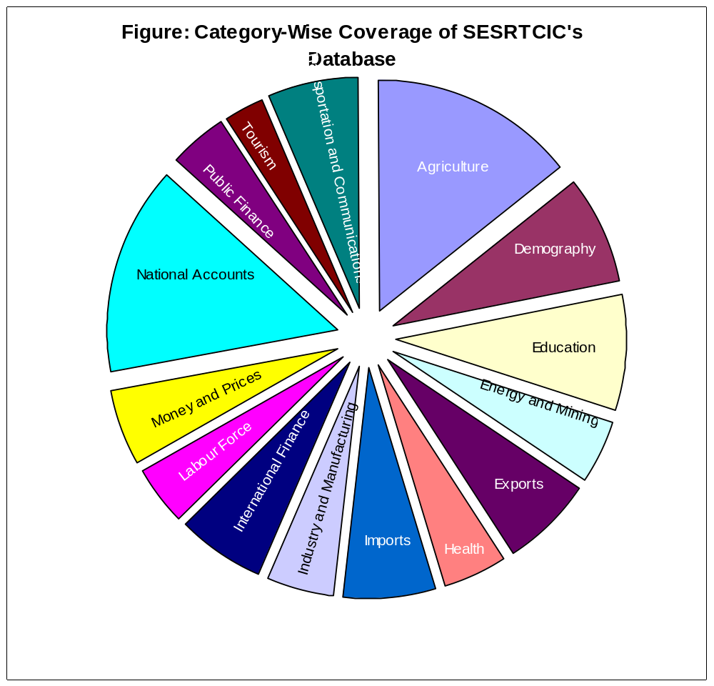

Turkey comes first in terms of data reporting (on all sectors) followed by Pakistan, Morocco, Malaysia, Jordan, Indonesia, Egypt, Tunisia, Syria, Saudi Arabia, Oman, Nigeria, Kuwait, Iran, Cameroon, Bangladesh, Bahrain, Algeria, Qatar, UAE. On the other hand, Cote d’Ivoire, Djibouti, Guyana, Palestine, Somalia, Suriname, Tajikistan, Turkmenistan and Uzbekistan rank last in this respect.

4. A Framework for Capacity Building

The training activities which were presented in Part 2 of this paper will continue. As reported in the Table of that part, the last training programme will took place in September. The Center is planning to make a new survey after then with the hope of a response rate which will be higher than 35% so that it would be possible for the Centre to involve more countries in the programme.

SESRTCIC has contacts with several other international organizations regarding their training programmes and the Centre is trying to create the best way of coordination with these organizations. A coordination with the Islamic Development Bank (IDB) can also be possible.

Depending on the outcomes of the e-learning programme of the World Bank new Statistical Capacity Building techniques will be promoted.

One of the indicators of progress in terms of data collection is the development of new data series since it reflects that the data provider institution is following the trends of the world. Since Millenium Development Goals are among the most important topics of the World’s agenda, the indicators of those goals which are missing in the database of SESRTCIC will be added. Moreover issues like environment and science and technology are important concerns of the countries so indicators related to these subjects will also be added to the database.

Methods of data collection will be improved through an ongoing project which is carried out in cooperation with the NSO of Turkey. At the recent stage of the initiative, a computer programme is being prepared. This programme will enable the data transfer of each OIC member country to SESRTCIC. During this transfer, the cooperation of NSOs of the member countries are very much needed and SESRTCIC will do its best in order to build the necessary requirements. It is possible to introduce the programme to the Director Generals of most of the NSOs of the member countries of OIC during the OECD World Forum which will take place at the end of June in Istanbul.

5. Conclusion

Various organizations are collecting and disseminating data for Islamic countries. In fact to have several data providers is a waste of resources and human energy. This fact is realized by most of the international organizations like World Bank, IMF, UN, FAO and etc. They are in the process of sharing what they have through a system which is named as SDMX.

OIC gave the task of statistical data collection to SESRTCIC. The quality and the extent of the database can be improved if coordination with IDB and also with other international organization is provided. The number of people visiting the website of SESRTCIC is at a considerable level (1000 people per day) so it is very much desirable that data about Islamic countries should disseminate to the world through this website. A proper and reliable data provision system may also increase the number of researchs on the member countries of OIC.

Appendix 1

QUESTIONNAIRE ON ASSESSING THE TRAINING NEEDS AND CAPACITIES
(Electronic version can be downloaded from www.sesrtcic.org/questionnaire)

- For each of the subjects/areas below, please indicate if your institution can offer training (check the box ‘Can Offer Training’) or if your institution needs training (check the box ‘Need’ under ‘Training Needed’). Please also specify the priorities by using a 1-to-4 scale (1 for the most urgent, 4 for the least urgent) by noting that you may assign the same priority rank to more than one subject. Please also specify the number of personnel to be trained in case of an in-house training arrangement.

Subjects/Areas | Can Offer Training | Training Needed
Subjects/Areas | Can Offer Training | Need | Priority Rank | Number of Personnel
General Statistics
National Accounts
Balance of Payments Statistics
International Trade Statistics
Monetary and Financial Statistics
Government Finance Statistics
Real Sector Statistics
Price Statistics
Agriculture Statistics
Education and Training Statistics
Industry and Services Statistics
Labor Statistics
Environmental Statistics
Health Statistics
Science, Technology and Patent Statistics
Population and Demography
Web-based Data Compilation Techniques
Statistical Data Analysis
Quality in Statistics
Statistical Organization
Census/Surveys and Sampling Techniques
Other (please specify the subjects below)

- Please provide us with the most recent contact information of your institution:
Name of Institution:
Phone: Fax:
Web Address: E-mail:
Mailing Address:

3. Please send us the names of the people from your institution to be included in our mailing list:
Name: Name:
E-mail: E-mail:

Appendix 2

OUTCOME OF THE SURVEY ON THE TRAINING NEEDS AND CAPACITIES OF THE NSOs OF THE MEMBER COUNTRIES OF OIC

Subjects/Areas | Countries which declared need for training | Number of personnel to attend the training | Countries which declared capacity for training
General Statistics | Maldives | 32 | Egypt
 | Bangladesh | 20
 | Sudan | 15
National Accounts | Indonesia | 40 | Morocco
 | Maldives | 15 | Senegal
 | Sudan | 15 | Maleysia
 | Yemen | 10
 | Albania | 8
 | Bangladesh | 5
Balance of Payments Statistics | Sudan | 15
 | Yemen | 10 | Yemen
International Trade Statistics | Yemen | 20 | Turkey
 | Sudan | 15
Monetary and Financial Statistics | Sudan | 15
 | Yemen | 10
Real Sector Statistics | Sudan | 15
 | Yemen | 15
Price Statistics | Bangladesh | 10 | Djibouti
 | Sudan | 15 | Morocco
 |  |  | Palestine
 |  |  | Turkey
 |  |  | Senegal
Agriculture Statistics | Sudan | 15
 | Bangladesh | 10
 | Yemen | 10
Industry and Services Statistics | Sudan | 15
 | Yemen | 15
Labor Statistics | Yemen | 15 | Turkey
 | Sudan | 15 | Palestine
 | Morocco | 12 | Morocco
 | Jordan | 6
 | Bangladesh | 5
Health Statistics | Sudan | 15 | Palestine
 | Bangladesh | 10
Population and Demography | Sudan | 15 | Palestine
 | Bangladesh | 10 | Senegal
 | Jordan | 7 | Yemen
 |  |  | Egypt
Web-based Data Compilation Techniques | Indonesia | 38 | Turkey
 | Sudan | 15
 | Azerbaijan | 12
 | Yemen | 10
 | Bangladesh | 5
Statistical Data Analysis | Indonesia | 40 | Senegal
 | Maldives | 29 | Uganda
 | Sudan | 15 | Palestine
 | Mozambique | 13
 | Jordan | 12
 | Albania | 10
 | Bangladesh | 10
 | Yemen | 10
Quality in Statistics | Indonesia | 40 | Egypt
 | Sudan | 15
 | Palestine | 5
 | Sudan | 15 | Yemen
Statistical Organization | Bangladesh | 5
Census/Surveys and Sampling Techniques | Indonesia | 40 | Yemen
 | Maldives | 17 | Senegal
 | Sudan | 15 | Egypt
 | Yemen | 15
 | Bangladesh | 10
 | Jordan | 8
 | Mali | 7

The countries which replied to the questionnaire are: Albania, Azerbaijan, Bahrain, Bangladesh, Djibouti, Egypt, Indonesia, Jordan, Kazakhstan, Maldives, Mali, Morocco, Mozambique, Palestine, Senegal, Sudan, Turkey, Uganda, Yemen

