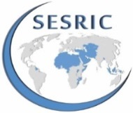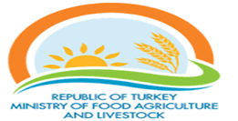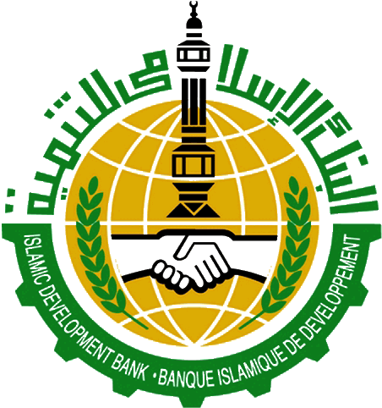

Concept Note on
“Study Visit on Development of Sustainable Aquaculture for OIC Countries”

Muğla and Izmir, Turkey
30 May – 03 June 2016

Introduction
Seafood is an important food item in terms of features it contains such as rich in protein, high-energy and easy digestibility, multiple vitamins and minerals. It is estimated that the stocks of fisheries will not increase substantially in the near future as a result of water polution, overfishing, climate change, and other environmental threats. Managing fisheries stock and increasing aquaculture production seem crucial to meet the needs of growing demand for fish due to growing population in the world.

World fish production is 163 million tones in total; 93 million tons of which derived from fisheries, while 70 million tones derived from aquaculture in 2013. In other words, about 43% of the total fish production is obtained from aquaculture. According to the Food and Agriculture Organization (FAO), it is estimated that 50% of the fish to be consumed in 2018 will be obtained from aquaculture. It means that today, one of two fishes on dining table would be produced in the fish farms. Aquaculture is the fastest growing food production sector in the world. As a result of this rapid development, aquaculture sector has been playing an important role in terms of reduction of poverty and food security at the national, regional and global economy.

The fisheries sector of the OIC Member Countries is considered a very important sector for their economic, social and nutritional development. The fisheries resources can be drawn from marine and inland waters, as well as from aquaculture in fresh and marine waters. Marine waters border most of the member countries from all sides. These countries are adjacent to waters of three oceans: the Atlantic, the Pacific and the Indian Oceans and several seas, among them, the Mediterranean, the Red Sea, the Caspian and the Black Seas. They also have access to some of the most important rivers including the Nile, the Brahmaputra, the Tigris, the Euphrates, as well as huge natural and man-made reservoirs and inland lakes of Africa and Asia.

Trade trends in fish and fishery products in OIC Member Countries vary considerably from one sub-region to the other. In the South and Southeast region, Malaysia has a very high local consumption, along with the coastal areas and large urban centers, estimated at about 30 kg average per capita, while the Maldives has the highest annual fish supply in the world, 126 kg per person. Half of the fish landed in the market is fresh, while more frozen fish is being marketed. Fish utilization is also characterized by greater production of a wide range of value-added products or preparations, for both national and international markets.

Capture fisheries and aquaculture supplied the world with about 182.9 million tons of fish in 2012. During 2000-2011, the average per capita consumption of fisheries products in OIC Member Countries has increased from 10.2 to 14.4 kg registering a 41.2% increase. This growth pace compares favorably to other developing countries where the average per capita consumption has increased from 14.1 to 18.0 during the same period (28.4%). Again on the production side, OIC countries accounted for 16.5% of the total world fisheries production in 2012.

Turkey, as a country surrounded by sea on three sides, has a very rich potential aquaculture resources in terms of lakes, ponds, reservoirs, rivers and springs. There are approximately 26 million hectares of water area (1,394,559 hectares inland and 24,607,200 hectares sea) suitable for aquaculture and fisheries. According to 2014 data, the production was 537 thousand tons of which 302 thousand tons were obtained from fishery and 235 thousand tons obtained from aquaculture. About 43.8% of the total productions were derived from aquaculture. Aquaculture has shown a 99% increase in the 10-year period (2005-2014). The country follows the modern technology used in aquaculture in the world. In recent years, recirculating aquaculture systems (RAS) that have a number of advantages have also been used alongside to other aquaculture systems.

Objective
The major objective of the study visit is to share knowledge and experience among relevant institutions in member countries, get inspiring ideas, and develop relationship that will lead to further cooperation among institutions, NGOs, universities and private companies towards establishing an enabling environment for sustainable development of aquaculture in OIC Member Countries. For this, the study visit will hear the Turkish experience and expertise on fisheries and aquaculture, particularly the private sector involvement in the sector, along with visits to private farms and manufacturers of equipment. Furthermore, experts from member countries will share and address their experiences and challenges they face.

Programme
The programme will include farming system available used in aquaculture; recirculation aquaculture systems (RAS); developments at supporting industry providing input to aquaculture sector ( feed, tanks, cages, barge, filter, RAS); determination of potential aquaculture areas; seafood trade. For this purpose, experts from General Directorate of Fishers and Aquaculture, privates sectors, The Central Union of Aquaculture Producers’ Organizations and Exporters’ Association will make presentations. Technical visits will be carried out in Muğla and İzmir where marine fishes are cultured intensively by private sector.

Expected Development Results
- Several private fish farms visited
- Private companies producing fishing equipment and fish feed visited
- Fish processing factories visited
- Participants informed about Turkish aquaculture applications
- International fair for fish trade, processing, aquaculture and fisheries participated
- Private sector relations established
- Private sector partnership developed to set up joint fish farms
- New contracts for Turkish exports on fishery equipment and feed signed
- Reverse Linkage project to transfer Turkish expertise on related topics initiated

Partners
The Study Visit will be jointly organized by SESRIC and IDB, in partnership with the Department of Fisheries and Aquaculture of the Ministry of Food, Agriculture and Livestock of Turkey (MoFAL). Within the framework of the objectives of the study visit, SESRIC, IDB and MoFAL are particularly interested in furthering the relationship among member countries in order to enhance collaboration on aquaculture sector through enhanced network and parnership projects.

Participants
Participants will be from the relevant OIC Member Countries from the ministries related to aquaculture, the producer organizations, universities and the private sector. Three participants from each country will be invited.

Venue and duration
Study Visit will be held in Izmir and Muğla. The duration of the Study Visit will be 5 days (2 days in Muğla and 3 days in Izmir).

Proposed Budget:
Provider | Item | Total Price
IDB | Airfare | $50,000
SESRIC | Per diem+ Translation | $81,250
MoFAL Turkey | Lunch & Local Transfer | $16,100
Total |  | $147,350

