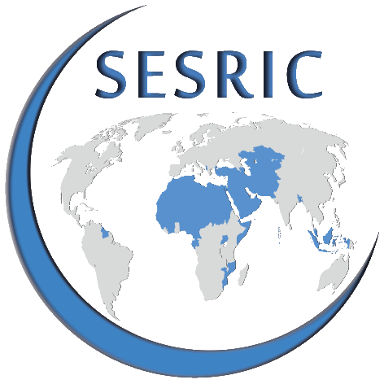


Fourth Session of OIC Statistical Commission

Ankara, Turkey 21-23 April 2014

PARTICIPATION FORM

Please fill in this form in capital letters for each participant in your delegation and
return one copy to secretariat@oicstatcom.org by 21 March 2014, at latest.

- CONTACT INFORMATION
Country
Institution
Participant | Name |  |  |  |  | Surname
Position/Designation
E-mail(s)
Mobile Phone | Country Code |  |  | City Code |  |  | Phone
Phone | Country Code |  |  | City Code |  |  | Phone
Fax | Country Code |  |  | City Code |  |  | Phone
Please also attach your CV/resume to the form.

- PASSPORT
Passport Holder | Name |  | Surname
Passport No
Date of Issue
Expiration Date
Do you need visa to enter Turkey?  Please check the below website:  http://www.mfa.gov.tr/visa-information-for-foreigners.en.mfa |  |  | YES
 |  |  | NO
Please also attach the soft copy of your passport to the form.

- SOCIAL EVENTS
Will you participate in the gala dinner organised by the Secretariat on 21 April 2014? | YES
 | NO
If YES, please specify the names of attendees including the accompanying people, if any, below:
Will you take part in the social program organised by the Secretariat on 23 April 2014? | YES
 | NO
If YES, please specify the names of attendees including the accompanying people, if any, below:

