Biography of Dr. Savaş Alpay, Director General, SESRIC

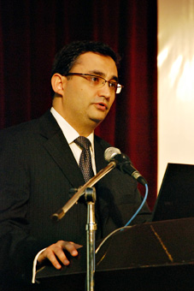
Dr. Savaş Alpay is the Director General of the Statistical, Economic & Social Research & Training Centre for Islamic Countries (SESRIC). He received his PhD in economics from Johns Hopkins University in 1997 and has taught at different universities in Turkey. Formerly, he has worked as a consultant for an international consultancy firm and served on the Board of a Public Regulation Authority in Turkey.
His research areas include environmental economics, trade and development economics, knowledge economics, science and technology policies in OIC Member Countries. His current research focuses on interactions among economic growth, international trade and the environment with an emphasis on the design and implementation of policies towards sustainable growth.
His book titled “Trade and the Environment” has been published by Kluwer, and he has many articles published in different journals and conference proceedings. He also serves as a referee for many leading journals in the environmental economics field.

