Third Arab Forum for Capacity Buildings and Development
and
OECD World Forum Middle East and North Africa Regional Conference
April 17-19, 2007

What is Real Progress?

By

Sıdıka Başçı (Ph. D)
SESRTCIC

In an increasingly globalised world with new challenges at the international level, the term “progress”, particularly of “societies” must be clearly understood and re-defined. The traditional measures of progress such as the improvements in economic indicators of GDP per capita or trade balance, are still desired but not sufficient to refelecting the real progress of today’s societies. Sustainability and fairness (equal distribution of income) are among the new dimensions of progress. Social and environmental conditions are also important factors in this respect. Even the survival of human beings has become a subject of deep concern in a world with global warming and ozone depletion. These global common concerns show the interdependence of the countries where progress of societies can no longer be defined based only on the national conditions but also considering the global ones. The report of the UN Secratary General (2000) submitted to the UN Millenium Assembly also points out this fact by mentioning that each state not only bears responsibilities in relation to its own people but also collectively shares responsibilities for the whole planet.

Enlargement of the Conventional Tasks of Statisticians

National Statistical Organizations (NSOs) have an important role to play in compiling relevant statistics. NSOs collect data on a lot of indicators from a wide range of economic and social agents, to process and analyze these data, and to disseminate summary information for the use of a wide range of groups with different interests, particularly for the decision-makers at the national level. In most countries, NSOs, in order to perform the function of regular data collection, are involved in processes like censuses of population, agriculture and although, even in fairly centralized systems, many other central government ministries and departments may also collect data, it is the responsibility of NSOs to finalize the processes.

With the changes in the definition of progress, NSOs have to use new methodologies and techniques of data collection and processing. Since social and environmental conditions have the priority now, research on these areas started to increase. This situation caused the rise of the demand for data related to these areas and NSOs are the main institutions which should satisfy this new need. For example indicators like

- protected area to total surface area
- protected areas, sq. Km
- Carbon dioxide emissions
- Carbon dioxide emissions per capita
- Consumption of ozone-depleting
- Consumption of all ozone-depleting substances

were not considered as important as today ten years ago and even were not thought as crucial indicators to be included in databases. As another example, like the share of manufactures or agriculture in exports and imports, the share of high technology products in exports and imports are started to be seen now in many databases as indicators of progress in Science and Technology (S&T). Millenium Development Goals raised the importance of a number of indicators such as number of undernourished persons, dietary energy consumption and Contribution of carbonhydrates, proteins or fats in total dietary energy consumption

These examples and many other show that one of the conventional tasks of the NSOs, which is compiling relevant statistics, have been enlarged. Ways to obtain these new indicators in the best way possible should be discovered and steps should be taken to activate necessary requirements.

A Non-Conventional Task for the Statistician

Both of the current prosperity and future achivements of the nations heavily depend on Research and Development (R&D) activities. Almost all differences in the level of development across countries are the outcome of differences in the levels of S&T, which are closely linked with the levels of R&D activities.

Figures 1 and 2 summarize the different aspects of R&D activities across developed and devoloping countries as well as different regions. Figure 1 shows that there is a very significant gap between developed and developing countries in terms of both expenditure on and number of researchers involved in R&D activities.

Figure 1: World GDP, Population, and R&D Expenditure and Personnel

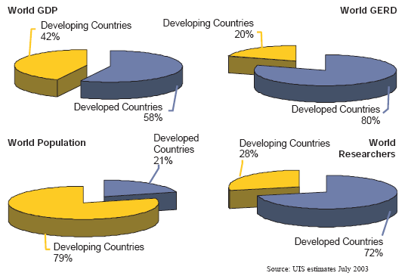

Figure 2: Share of World Gross Expenditure on R&D, (2000)

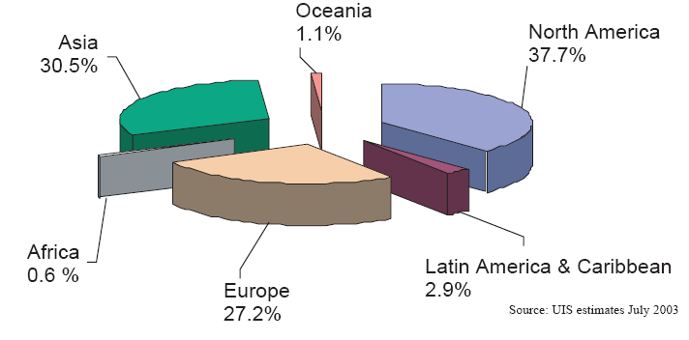

Figure 2 indicates that Nort America, Asia and Europe give more importance to R&D compared to other parts of the world. Coming to the situation for the OIC member countries, Figure 3 shows that the average of R&D expenditure as the share of GDP is only 0.35% which is far behind the world average of 1.79%.

Figure 3: GERD as Share of GDP (%)*


2,33
1,89
1,79
1,73
1,64
0,35
0,00
0,50
1,00
1,50
2,00
2,50
3,00
OECD
EU-15
World
Europe
Asia
OIC
Source: UIS S&T database, World Bank, Calculations are made by SESRTCIC
* Data are for the most recent year available

These differences can be narrowed down only by developing, managing and properly applying appropriate knowledge. As above observations also support, it is almost impossible for countries to achieve and sustain prosperity and a high quality of life without giving adequate importance to S&T development and ensuring a well-educated population. It can easily be argued that the most important aspect and determinant of progress of societies is transition to knowledge-based economies and societies. The factors that determine the speed and duration of this transition need to be identified considering different characteristics of the countries. As an example, to be consistent with the above overall figures, the relationship between the R&D activities and GDP per capita for some of the OIC countries are presented in Tables 1 and 2.

Table 1: The relationship between R&D expenditures and GDP
per capita (1997-2004)*

Country | Share of R&D (%) | GDP per Capita
Uganda | 0,81 | 225
Malaysia | 0,69 | 3.884
Iran | 0,67 | 2.362
Turkey | 0,66 | 2.675
Tunisia | 0,63 | 2.153
Morocco | 0,62 | 1.237
Mozambique | 0,59 | 222
Sudan | 0,34 | 551
Azerbaijan | 0,30 | 760
Kazakhstan | 0,22 | 1.490
Pakistan | 0,22 | 502
Kuwait | 0,20 | 15.753
Kyrgyzstan | 0,20 | 321
Egypt | 0,19 | 1.550
Burkina Faso | 0,17 | 260
Indonesia | 0,05 | 773
Brunei | 0,03 | 18.800
*Data are for the most recent year available

Table 2: The relationship between R&D personnel and GDP
per capita (1997-2004)*

Country | Researchers and Technicians Employed in R&D (per million People) | GDP per Capita
Iran | 4.782 | 2.362
Tunisia | 2.903 | 2.153
Jordan | 2.636 | 1.731
Kazakhstan | 1.760 | 1.655
Turkey | 1.445 | 2.675
Azerbaijan | 1.431 | 760
Brunei | 1.091 | 18.800
Morocco | 782 | 1.237
Indonesia | 645 | 773
Kyrgyzstan | 457 | 321
Sudan | 394 | 657
Malaysia | 357 | 3.884
Guinea | 342 | 391
Kuwait | 241 | 15.753
Saudi Arabia | 140 | 8.785
Mozambique | 132 | 222
Gabon | 109 | 5.505
Pakistan | 86 | 502
Bangladesh | 77 | 336
Uganda | 38 | 225
Burkina Faso | 33 | 260
*Data are for the most recent year available

Although most of the countries in Tables 1 and 2 have the charecteristics of positive correlation between R&D activities and GDP per capita, Uganda, Kuwait, Brunei, Saudi Arabia and Gabon reflect different characteristics. The correlation coefficient between R&D expenditures and GDP per capita, when all the countries in Table 1 are included, is -0.33, which is surprising at first glance but when the outlier countries, Uganda, Kuwait and Brunei are excluded from the analysis, the correlation coefficient becomes 0.65 as expected. A similiar scene exists for Table 2 also. When all the countries in Table 2 are included in the analysis, the correlation coefficient between number of researchers and GDP per capita is -0.05 but when the outlier countries, Brunei, Kuwait, Saudi Arabia and Gabon are excluded from the analysis the coefficient becomes 0.53. This simple analysis indicates that there is a value to focus on indicators related to S&T development by the NSOs and so they should inform the policy makers on the performnace of their own countries in this important area.

In today’s world with unprecedented technological changes, there is very frightening divergence in the levels of progress across developed and developing countries. It is not only important to identify how we measure progress, and that we facilitate progress in all countries but also to tackle the current biased form of progress across countries; that is to say, how we norrow down the big gaps across developed and developing countries. In this connection we can talk about a significant and maybe unconventional role for the NSOs monitoring the trends to identify new technological developments and new revolutionary waves and inform the decision-makers in a timely manner so that their countries can take their parts in the new developments.

Progress and the Role of International Organizations

With the enlargement of conventional tasks and introduction of the non-conventional tasks, ensuring that the NSOs be equipped with the required technical and human capacities becomes very important. With respect to the human resource development, NSOs may start with the identification of the needs determined by current and planned activities and targets, and the analysis of strengths and weaknesses. Then, as a second step, it can be possible to undertake capacity building activities. International organizations may play a vital role in making these transitions for the NSOs more effective as they have interactions with both the developed and developing countries as well as accumulated exprience and expertise. Additionally, multilateral organizations may also play a coordination role in matching the needs and capacities of different countries in various areas of training and capacity building activities.

The OECD World Forum Project is important and very timely in bringing different aspects of progress into our attention. If these critical issues are handled in an effective manner, the Forum will make an important contribution to all countries by fostering a global conversation about what progress actually means and how it should be approached.

Countries are chosen depending on the availability of data.

