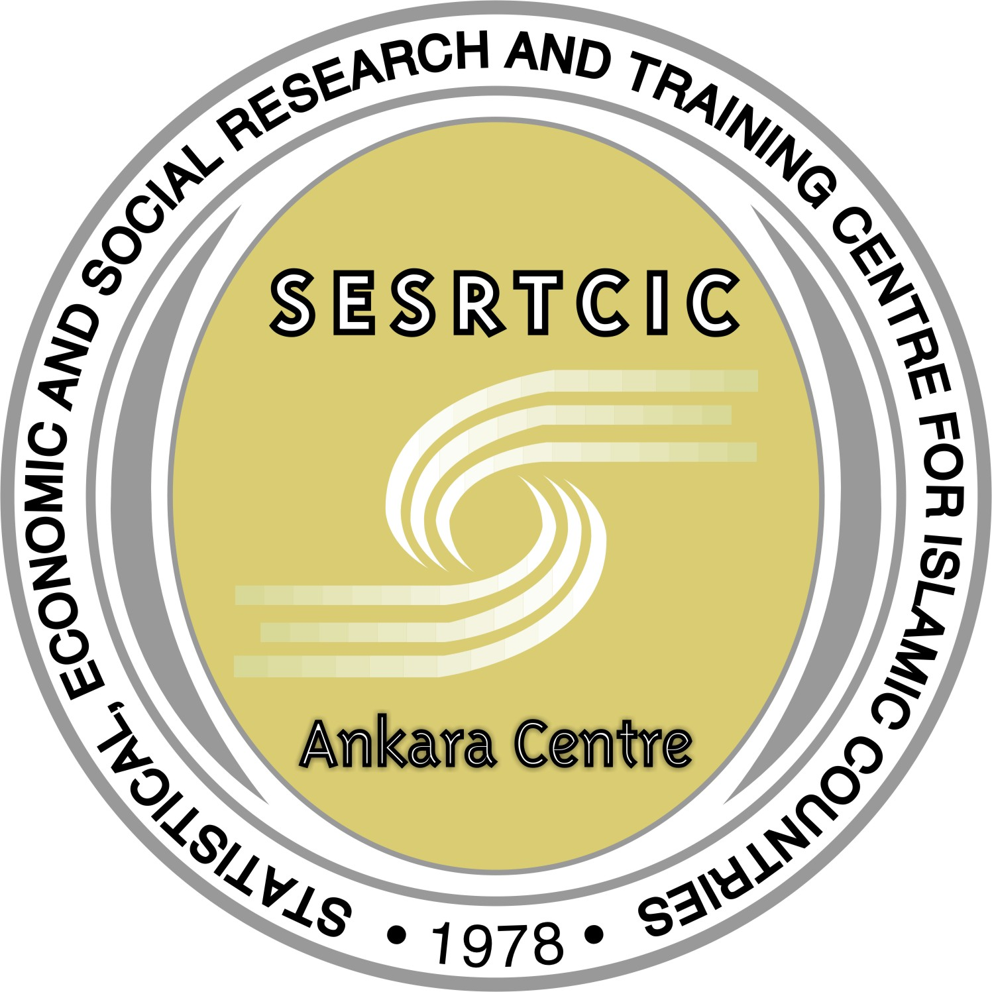  SESRTCIC | SESRTCIC  STATISTICAL, ECONOMIC AND SOCIAL RESEARCH  AND TRAINING CENTRE FOR ISLAMIC COUNTRIES  (ANKARA CENTRE)

DRAFT PROGRAMME

Theme : Statistical Capacity Building
Date : 04 May 2007

08:30- | - Opening  - Election of chair and rapporteur  - Introductory remarks by SESRTCIC  - Country experiences in statistical capacity building  a- UGANDA (TBC)  b- NIGER (TBC)  - Discussion
10:30 | Coffee break
11:00 | The Role of International Organizations in Statistical Capacity Building  - WORLD BANK (TBC)  - UNECA (TBC)  - PARIS21 (TBC)  - IMF – AFRITAC (TBC)  - AFRICAN DEVELOPMENT BANK (TBC)  - Discussion
13:00 | Lunch
14:30 | -Improving Statistical Capacity Building Activities: Future Works  a- MOROCCO (TBC)  b- AFRISTAT (TBC)  c- SUDAN (TBC)  d- FAO (TBC)  - Discussion
16:00 | Coffee break
16:30 | - Adoption of Report;  Closing

