2013 MEETING OF THE CENTRAL BANKS AND MONETARY AUTHORITIES OF OIC MEMBER COUNTRIES

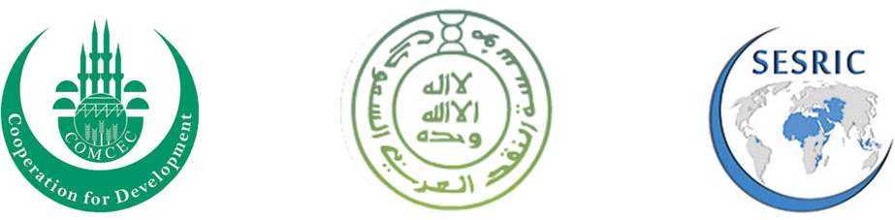
Registration form
Expert Workshop & Governors meeting on
“Impact of Recent International Financial Regulatory Reforms on OIC Countries”

Mr. Mrs. Ms.
Name: Family Name:
Title:
Institution:
Address:
Telephone: Fax:
Email: Mobile:

I will attend the Experts Workshop on Wednesday 27 Nov. starting at 8:30 A.M. Yes No
I will attend the welcoming dinner on Wednesday 27 Nov. at 8:00 P.M. Yes No
I will attend the Governors’ Meeting on Thursday 28 Nov. starting at 8:30 A.M. Yes No
I will attend Umrah program 26th at 5:00 P.M. 28th at 2:00 P.M. No

Travel and Transportation

Arrival Jeddah City Date/day: Time: Flight No.:
Departure Jeddah City Date/day: Time: Flight No.:

Note: Please be informed that SAMA will provide Airport Transfer for all meeting delegates.
A block booking has been made by SAMA at the Jeddah Hilton Hotel and Albilad Hotel, Jeddah at special rates and SAMA will arrange hotel reservations for meeting delegates.
Please check your hotel room preference:
Hilton Hotel:
Single Room (1050 SR): Executive Room (1450 SR): King Al Sultan Suite (3000 SR):
Albilad Hotel: Single Room (520 SR):

Please return completed form no later than Monday October 21st, 2013 to
Mr. Suliman Al-Saeed, Relations Director at ssaeed@sama.gov.sa and SAMA Secretariat at prd@sama.gov.sa; Fax # +966 11 466 2040

Logistical Information
Meeting schedule
The Meeting of the Central Banks and Monetary Authorities of OIC Member Countries will take place on 27-28 November 2013 in Alkaser Meeting Room (ground floor) at Hilton Hotel North Corniche Road, Jeddah, Kingdom of Saudi Arabia. Please note that the access to the Governors Meeting room will be limited to two; the head of the delegates accompanied by one person.
Visas
The meeting delegates requiring Saudi Arabian Visa should send by e-mail the filled-in “Visa Requirement Form” (attached) along with a pdf copy of the Passport, by October 21st, 2013 to SAMA (at ssaeed@sama.gov.sa and prd@sama.gov.sa). SAMA will then send by email an electronic copy of the Visa Slip to the delegates within about 10 days of receiving the Form.
On receiving their Visa Slip, the delegates should apply for the Visa to the Saudi Arabian Embassy in their own country, in the prescribed application form along with the required documents, through a travel agent accredited by the Saudi Arabian Embassy (as per the new policy of Ministry of Foreign Affairs of Saudi Arabia). Kindly contact the Embassy of Saudi Arabia in your country to get the particulars of the accredited travel agents and the processing time required for the Visa.
Each person accompanying the Head of a delegation (partner or staff) should send a separate Visa Requirement Form for the visa. The delegates are encouraged to apply for Visa at the earliest convenience.
Airport and Immigration
Delegates should provide their accurate and complete flight details (the name of the airline, flight number, arrival and departure dates and time) in the registration form to enable their reception at the airport.
At the airport, the head of the delegation will be received by the SAMA staff members, who will be carrying placards with the name of the Head of the delegation. If the persons accompanying the Head of a country delegation travel by a different flight, there will be drivers waiting in the arrival area carrying placards with the name of the delegates who will pick you up to the hotel. Please approach them on your arrival at the airport.

Should you fail to locate them for any reason, please contact Suliman Al-Saeed at his mobile +966508584545.
Accommodation
SAMA will arrange hotel reservation for meeting delegates, only at the Jeddah Hilton Hotel and Albilad Hotel, Jeddah.

Administrative contacts
At the SAMA Secretariat:
Suliman Al-Saeed  Email: ssaeed@sama.gov.sa  Tel.: +966 11 466 2075  Fax: +966 11 466 2040 | Relations Dept.  Email: prd@sama.gov.sa  Tel.: +966 11 466 2075  Fax: +966 11 466 2040

