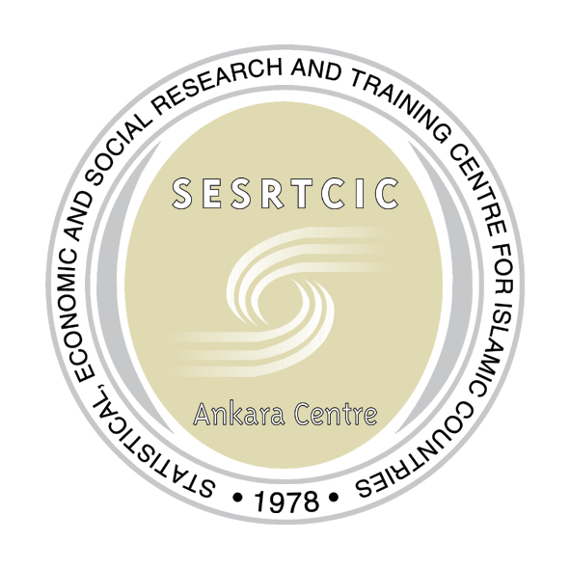 | SESRTCIC  STATISTICAL, ECONOMIC AND SOCIAL RESEARCH  AND TRAINING CENTRE FOR ISLAMIC COUNTRIES  (ANKARA CENTRE)

INFORMATION FOR PARTICIPANTS

DATE & VENUE
The Workshop will take place from 9 to 11 July 2007 at Kalyon Hotel in Istanbul, Turkey.

Address:
Sahilyolu, Sultanahmet
Istanbul – Turkey
Tel: (90-212) 517 44 00
Fax: (90-212) 638 11 11

TRAVEL AND ACCOMODATION FOR PARTICIPANTS
Travel and accommodation arrangements should be finalized on 22 June 2007 latest. If you need additional information please send an e-mail to:
microfinance@sesrtcic.org

VISAS
Visas can be obtained from consulates of the Republic of Turkey or in the Consular Section of the Embassy of the Republic of Turkey in the respective countries. Information on visa requirements can be found at http://www.mfa.gov.tr/MFA/ConsularInformation/ForForeigners/VisaInformation/. The Ministry of Foreign Affairs of Turkey also offers E-Consulate services at http://www.e-konsolosluk.net/Visa/Visa_Query.aspx

ARRIVAL
Participants will be met at the Istanbul International Ataturk Airport by SESRTCIC Staff, and escorted to the Kalyon Hotel.

WORKSHOP REGISTRATION
The registration of workshop participants will take place upon arrival through a dedicated Registration Desk in the Kalyon Hotel from 18.00 to 20:00 p.m. on 8 July 2007. Late arrivals can register from 8.30 to 9.00 a.m. on 9 July 2007, prior to the beginning of the workshop.

WORKING LANGUAGE
The working language of the workshop is English.

ADDITIONAL INFORMATION
Local Time is GMT+2. Temperature in Istanbul on July is expected to be around 19-28 degrees Celsius.
The local currency is the Turkish Lira TRL. 1 USD ~= 1.32 TRL. 1 Euro ~= 1.78 TRL
Voltage: 220 V

REGISTRATION FOR NEW PARTICIPANTS
If you consider participating in the workshop please send an e-mail to:

microfinance@sesrtcic.org

